***Summary of Our Findings***

1. Is there a strong correlation between school rankings and per income per capita in Southeast states at county level?

Initially our hypothesis was that there must be strong relation between school success level and income level of states. However, when we calculate correlation coefficient between two metrics, r-value is calculated as 0.11 which shows very low level of correlation.

R-Value: 0.11539404232528741

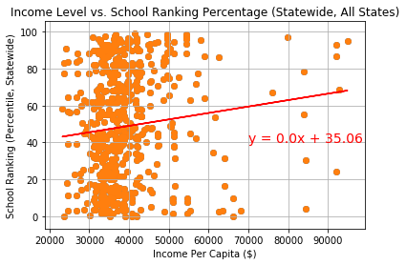

1. We looked at the correlation for two metrics for Georgia as a sample of our dataset to compare it to our finding for Southeast region. Calculating correlation coefficient for Georgia, we had same trend as in Southeast region.

R-Value: -0.020077467636628668

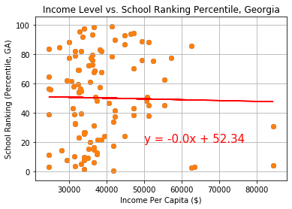

1. We tried to find out if low correlation between income and school rankings is exist at school level in Southeast. Creating at the scatter plots, we find out that same trend is continuing through elementary, middle and high schools.

